**Raspberry Pi Web Application that Controls LEDs**

In this project, you’ll create a web page with clickable buttons that control two LED lights.

**Parts Required**

* Breadboard
* 2 LED lights (red, green, yellow, or blue)
* 2 220Ω resistors (red/red/brown)
* 3 male/female jumper wires (any color)

**\*\*\*Always make sure that your Pi is shut down and unplugged before connecting any wires to it!**

**Setup**

The setup for this project is similar to that in our Introduction course. You can use the Quick-Start Guide included in your Raspberry Pi kit as a reference.

Connect two LEDs on the breadboard to **pins** **GPIO 23** **and** **GPIO 24** **on the Raspberry Pi** using two of the male/female jumper wires and two red/red/brown resistors, as the figure below illustrates. Pay attention to the polarity of the LEDs.

Connect the third male/female jumper wire from the breadboard to **a ground (GND) pin on the Raspberry Pi**.

Once finished, plug in your Pi to power it on.

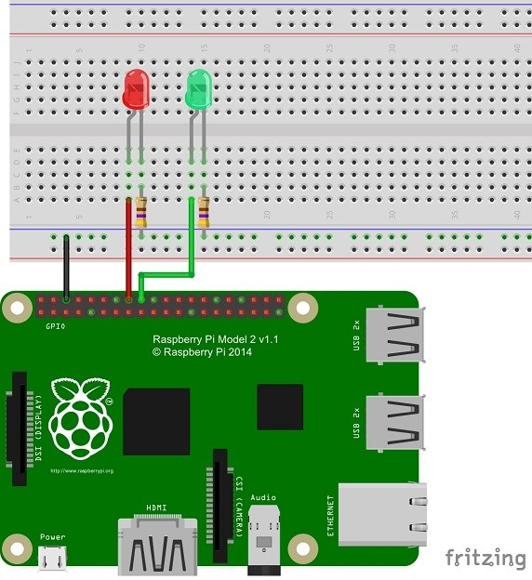

***Note: the color of the resistors in this photo are incorrect

**Connect to WiFi**

One of the icons on the desktop taskbar is the WiFi icon. Connect to the appropriate network in the drop-down menu.

**Make the Required Folders**

Open the **Terminal** program from the desktop taskbar or from the **Accessories** menu in the Pi main menu.

Here are the commands we will use to create the folders we need and to navigate in and out of them:

|  |  |
| --- | --- |
| **Command** | **Explanation** |
| **mkdir** *folder name* | Creates an empty folder with the specified name |
| **cd** *folder name* | Navigates into the folder with the specified name |
| **cd** *..* | Navigates into the previous folder |

From the terminal, first **create an empty folder called** ***pi-camp-projects*** by typing the following command:

pi@raspberrypi ~ $ **mkdir pi-camp-projects**

Then **navigate into the *pi-camp-projects* folder**:

pi@raspberrypi ~ $ **cd pi-camp-projects**

Repeat that process to **create an empty folder called *web-server*** inside the pi-camp-projects folder and **navigate into it**:

pi@raspberrypi:~/pi-camp-projects $ **mkdir web-server**

pi@raspberrypi:~/pi-camp-projects $ **cd web-server**

Finally, inside the web-server folder, **create an empty folder called *templates***:

pi@raspberrypi:~/pi-camp-projects/web-server $ **mkdir templates**

Leave the terminal open. We will be coming back to it in a moment.

**Download the Required Files**

Open Chromium or another web browser and type the following URL into the address bar: . Download the required files and put them in the appropriate folder according to the table below:

|  |  |
| --- | --- |
| **File name to download** | **Folder name to put the file in** |
| app.py | web-server |
| main.html | templates |

You can leave the web browser open. We will be using it again in a later step.

**Launch the Web Application**

Go back to the terminal you left open. You should still be in the templates folder. **Navigate into the previous folder (*web-server*)** by typing the following command:

pi@raspberrypi:~/pi-camp-projects/web-server/templates $ **cd ..**

Now it’s time to launch your web application! To do so, type the following command:

pi@raspberrypi:~/pi-camp-projects/web-server $ **sudo python app.py**

The information that shows up next will show you that your application is running, as the image below illustrates. Leave the terminal open so that the application will continue to run.

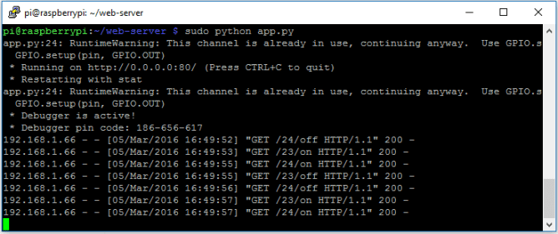

**Visit the Website**

Now that our application is running, let’s see the web page that we created!

The URL for our web page is simply“localhost.” In Chromium or another web browser, type **localhost** in the address bar and hit Enter. Your web page should look like this:

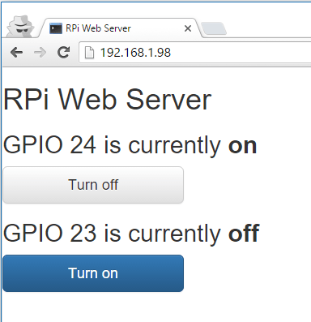

**Click the buttons to see your LEDs turn on and off!**

From here you can edit the app.py and main.html files if you would like to play around with adding more buttons/LEDs.

**Shut Down the Web Application**

When you’re finished, in the terminal where the application is running, simply type **Ctrl+C** to shut it down.

**Clean Up the Files and Folders**

It would be helpful to clean up the folders you created so that the next Pi user has a clean slate to start with.

In the terminal, you should be in the web-server folder. **Navigate into the previous folder (*pi-camp-projects*)** by typing the following command:

pi@raspberrypi:~/pi-camp-projects/web-server $ **cd ..**

Delete the web-server folder and all of its contents by typing the following command:

pi@raspberrypi:~/pi-camp-projects $ **rm –Rf web-server**

Simply type **exit** to close the terminal.